**Child Online Safety Policy**

E-Safety

This stands for electronic safety.

It is important because it helps us stay safe so we can enjoy, explore and have fun.

It keeps us safe on the internet in and out of school.

We need to know when strange things occur or when we should be worried.

Some online dangers are:

* Cyber bullying – nasty messages and comments, including swearing and unkind words.
* Stranger danger – people who we do not know online.
* Bad language
* Inappropriate content – some material isn’t suitable for children.

The internet is great because:

* You can learn lots of things
* You can have lots of fun
* It can help with our school work.
* You can keep in touch with friends and family.





What should I do?

* Tell an adult you trust
* Stay calm
* Report things that worry you.
* Ignore the person
* Block and delete
* Keep messages as evidence.

Who can I speak to in school?

* Mrs Thomas (SENDCo)
* Mrs Kendell (Headteacher)
* Mr. Cowling (Computing Lead)
* Any trusted adult
* All adults will investigate the concern and support your concerns.



What shouldn’t I do?

* Do not keep worries to yourself.
* Don’t be nasty or unkind back.
* Do not get angry or upset.
* Do not delete messages.

**Our Internet Rules**

* Ask permission before using a device.
* Use websites that an adult has asked you to use.
* Polite and friendly to one another online.
* Speak to an adult if we are unhappy with anything.

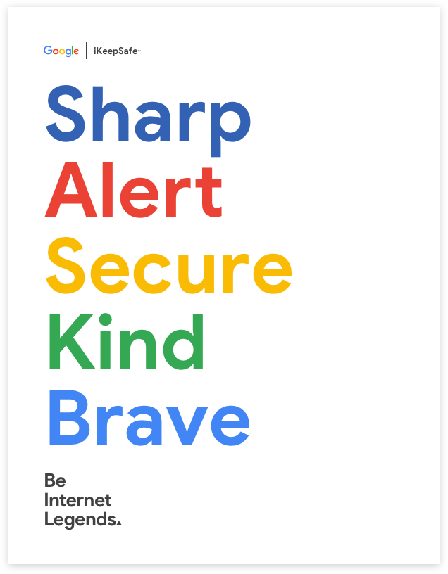

* Be ‘Sharp’ – Treat online communication the same as face-to-face. If it isn’t right to say, it isn’t right to post
* Be ‘Alert’ – People aren’t always as they seem.
* Be ‘Secure’ – Privacy and security are important online like the real world.
* Be ‘Kind’ – Treat others as you would like to be treated, online and offline.
* Be ‘Brave’ – Feel comfortable talking to a trusted adult about anything.